Потыкать интерфейс: ForRobot\bin\Release
Библиотеки (возможные):
- StreamJsonRpc (???);
- JSON-RPC.NET (???);

WebSocketSharp (???);
- SSH.NET (???).
На отдельном ПК: да
Сценарий:
- Изменяется переменная в интерфейсе;
- Отправлять команды с передачей праметров в putty:
  - Аргументом в процесс (сомниттельно);
  - Через библиотеку JSON-RPC.NET
- Или в обход putty, через SSH.NET
- Дальше надо смотреть как работает основная программа и как данные будут приниматься
Полезное:
- https://stackoverflow-com.translate.goog/questions/27592329/run-unix-commands-using-putty-in-c-sharp?_x_tr_sl=auto&_x_tr_tl=ru&_x_tr_hl=ru (отправка команд в putty входящим аргументом)
- https://stackoverflow-com.translate.goog/questions/30883237/how-to-run-commands-on-ssh-server-in-c?_x_tr_sl=auto&_x_tr_tl=ru&_x_tr_hl=ru#44797940 (пример использования SSH.NET)
- https://github-com.translate.goog/sshnet/SSH.NET?_x_tr_sl=auto&_x_tr_tl=ru&_x_tr_hl=ru (SSH.NET)
- https://github.com/Astn/JSON-RPC.NET/wiki/Getting-Started-(Sockets) (JSON-RPC.NET)

- https://www-tpeczek-com.translate.goog/2020/06/json-rpc-in-aspnet-core-with.html?_x_tr_sl=en&_x_tr_tl=ru&_x_tr_hl=ru&_x_tr_pto=sc (про JsonRCP в C#)
- https://www-appsloveworld-com.translate.goog/csharp/100/465/jsonrpc-client-over-websocket-c?_x_tr_sl=en&_x_tr_tl=ru&_x_tr_hl=ru&_x_tr_pto=sc (и WebSocket)
- https://jonathancrozier-com.translate.goog/blog/implementing-the-request-response-pattern-using-c-sharp-with-json-rpc-and-websockets?_x_tr_sl=en&_x_tr_tl=ru&_x_tr_hl=ru&_x_tr_pto=sc (JsonRCP и WebSocket)
- https://github.com/09th/KRC-RPC/tree/main?tab=readme-ov-file
- https://github.com/Montellese/xbmc-jsonrpc-sharp/blob/master/xbmc-jsonrpc-sharp/Player/XbmcPlayerState.cs
- https://github-com.translate.goog/xunit/xunit/issues/2587?_x_tr_sl=en&_x_tr_tl=ru&_x_tr_hl=ru&_x_tr_pto=sc
- https://stackoverflow-com.translate.goog/questions/38241875/task-wait-not-waiting-for-task-to-finish?_x_tr_sl=en&_x_tr_tl=ru&_x_tr_hl=ru&_x_tr_pto=sc (async без deadlock)

Вопросы:
- Хорошо… Т. е. пользователь изменяет переменную на интерфейсе → она где-то записывается, а потом при вызове программы считывается и программа с ней работаети Или я неправельно поняла? Я вооще про то как этот обмен данными будет устроен

- Вы ещё говорили, что неплохо было бы, чтобы и у пользователей на интерфейсе отображалось состояние данных. Как отслеживать, если они передаются, это понятно, а готовность передачи? Можно по запуску генератора, только тогда нужно чтобы при прерваном запуске генератор выдавал исключение, а интерфейс по его присутсявию показывал ошибку или готовность. Пойдёт?
- А при генерации новая программа — это перезапись старой или прям новая
Text="{Binding Path=SelectedRobot.Item2.PathControllerFolder, Mode=TwoWay, UpdateSourceTrigger=LostFocus}"

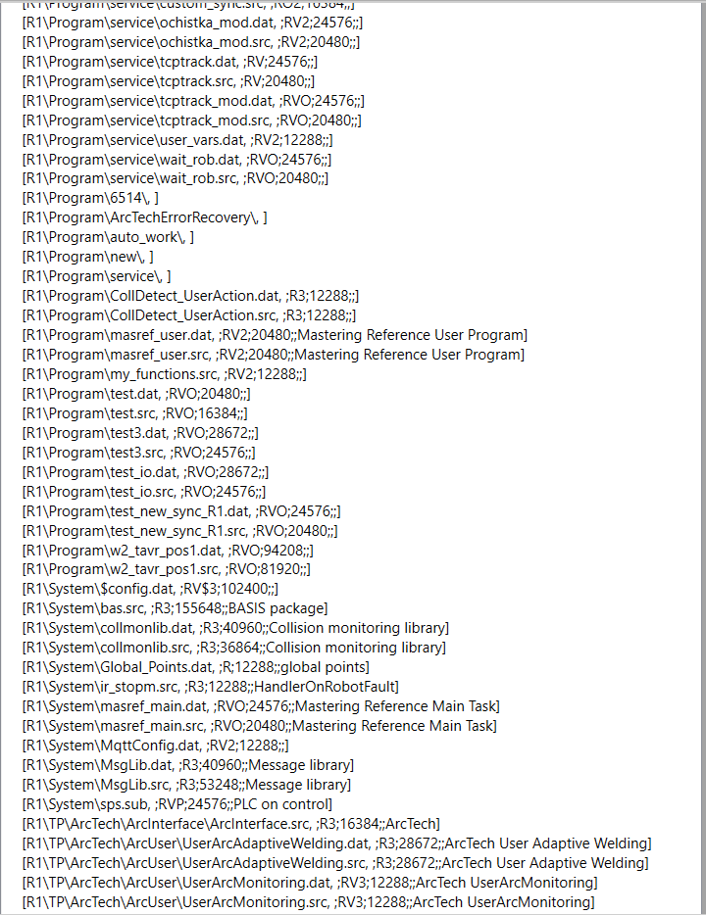
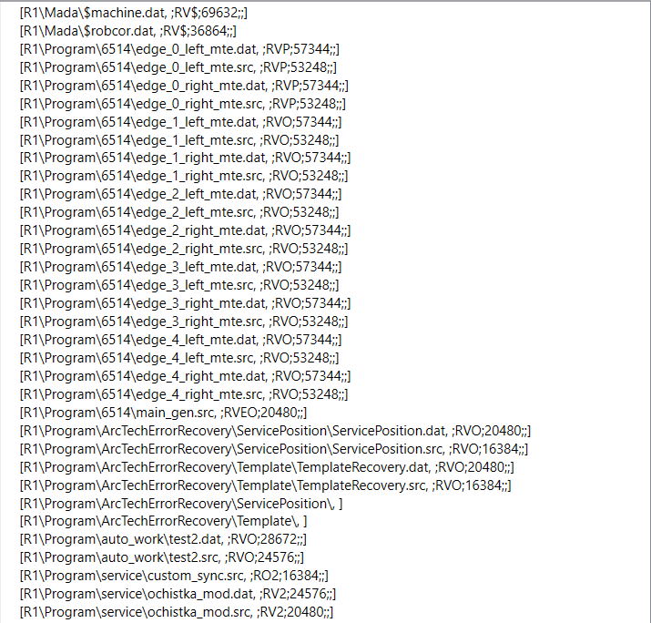

{""R1\\Mada\\$machine.dat":";ARV$;69632;;","R1\\Mada\\$robcor.dat":";ARV$;36864;;",
"R1\\Program\\6514\\edge_0_left_mte.dat":";RVO;57344;;",
"R1\\Program\\6514\\edge_0_left_mte.src":";RVO;53248;;","R1\\Program\\6514\\edge_0_right_mte.dat":";RVO;57344;;",
"R1\\Program\\6514\\edge_0_right_mte.src":";RVO;53248;;",
"R1\\Program\\6514\\edge_1_left_mte.dat":";RVO;57344;;",
"R1\\Program\\6514\\edge_1_left_mte.src":";RVO;53248;;",
"R1\\Program\\6514\\edge_1_right_mte.dat":";RVO;57344;;",
"R1\\Program\\6514\\edge_1_right_mte.src":";RVO;53248;;",
"R1\\Program\\6514\\edge_2_left_mte.dat":";RVO;57344;;",
"R1\\Program\\6514\\edge_2_left_mte.src":";RVO;53248;;",
"R1\\Program\\6514\\edge_2_right_mte.dat":";RVO;57344;;",
"R1\\Program\\6514\\edge_2_right_mte.src":";RVO;53248;;",
"R1\\Program\\6514\\main_gen.src":";RVEO;20480;;",
"R1\\Program\\ArcTechErrorRecovery\\ServicePosition\\ServicePosition.dat":";RVO;20480;;",
"R1\\Program\\ArcTechErrorRecovery\\ServicePosition\\ServicePosition.src":";RVO;16384;;",
"R1\\Program\\ArcTechErrorRecovery\\Template\\TemplateRecovery.dat":";RVO;20480;;",
"R1\\Program\\ArcTechErrorRecovery\\Template\\TemplateRecovery.src":";RVO;16384;;",
"R1\\Program\\ArcTechErrorRecovery\\ServicePosition\\":"",
"R1\\Program\\ArcTechErrorRecovery\\Template\\":"",
"R1\\Program\\auto_work\\test2.dat":";RVO;28672;;","R1\\Program\\auto_work\\test2.src":";RVO;24576;;",
"R1\\Program\\service\\custom_sync.src":";RO;16384;;",
"R1\\Program\\service\\ochistka_mod.dat":";RV;24576;;","R1\\Program\\service\\ochistka_mod.src":";RV;20480;;",
"R1\\Program\\service\\tcptrack.dat":";RV;24576;;",
"R1\\Program\\service\\tcptrack.src":";RV;20480;;",
"R1\\Program\\service\\tcptrack_mod.dat":";RVO;24576;;",
"R1\\Program\\service\\tcptrack_mod.src":";RVO;20480;;",
"R1\\Program\\service\\user_vars.dat":";RV;12288;;",
"R1\\Program\\service\\wait_rob.dat":";RVO;24576;;",
"R1\\Program\\service\\wait_rob.src":";RVO;20480;;",
"R1\\Program\\6514\\":"","R1\\Program\\ArcTechErrorRecovery\\":"",
"R1\\Program\\auto_work\\":"","R1\\Program\\new\\":"",
"R1\\Program\\service\":"",
"R1\\Program\\CollDetect_UserAction.dat":";R1;12288;;",
"R1\\Program\\CollDetect_UserAction.src":";R1;12288;;",
"R1\\Program\\masref_user.dat":";RV;20480;;Mastering Reference User Program",
"R1\\Program\\masref_user.src":";RV;20480;;Mastering Reference User Program",
"R1\\Program\\my_functions.src":";RVO;12288;;",
"R1\\Program\\test.dat":";RVO;20480;;",
"R1\\Program\\test.src":";RVO;16384;;",
"R1\\Program\\test3.dat":";RVO;28672;;",
"R1\\Program\\test3.src":";RVO;24576;;",
"R1\\Program\\test_io.dat":";RVO;28672;;",
"R1\\Program\\test_io.src":";RVO;24576;;",
"R1\\Program\\test_new_sync_R1.dat":";RVO;24576;;",
"R1\\Program\\test_new_sync_R1.src":";RVO;20480;;",
"R1\\Program\\w2_tavr_pos1.dat":";RVO;94208;;",
"R1\\Program\\w2_tavr_pos1.src":";RVO;81920;;",
"R1\\System\\$config.dat":";RV$1;102400;;",
"R1\\System\\bas.src":";R1;155648;;BASIS package",
"R1\\System\\collmonlib.dat":";R1;40960;;Collision monitoring library",
"R1\\System\\collmonlib.src":";R1;36864;;Collision monitoring library",
"R1\\System\\Global_Points.dat":";R;12288;;global points",
"R1\\System\\ir_stopm.src":";R1;12288;;HandlerOnRobotFault",
"R1\\System\\masref_main.dat":";RVO;24576;;Mastering Reference Main Task",
"R1\\System\\masref_main.src":";RVO;20480;;Mastering Reference Main Task",
"R1\\System\\MqttConfig.dat":";RV;12288;;",
"R1\\System\\MsgLib.dat":";R1;40960;;Message library",
"R1\\System\\MsgLib.src":";R1;53248;;Message library",
"R1\\System\\sps.sub":";RVP;24576;;PLC on control",
"R1\\TP\\ArcTech\\ArcInterface\\ArcInterface.src":";R1;16384;;ArcTech",
"R1\\TP\\ArcTech\\ArcUser\\UserArcAdaptiveWelding.dat":";R1;28672;;ArcTech User Adaptive Welding",
"R1\\TP\\ArcTech\\ArcUser\\UserArcAdaptiveWelding.src":";R1;28672;;ArcTech User Adaptive Welding",
"R1\\TP\\ArcTech\\ArcUser\\UserArcMonitoring.dat":";RV1;12288;;ArcTech UserArcMonitoring",
"R1\\TP\\ArcTech\\ArcUser\\UserArcMonitoring.src":";RV1;12288;;ArcTech UserArcMonitoring",
"R1\\TP\\ArcTech\\ArcUser\\UserArcSubRoutines.dat":";RV1;53248;;ArcTech User sub routines module",
"R1\\TP\\ArcTech\\ArcUser\\UserArcSubRoutines.src":";RV1;49152;;ArcTech User sub routines module",
"R1\\TP\\ArcTech\\ArcUser\\UserWeavePattern.dat":";RVO1;12288;;ArcTech User Pettern Figure",
"R1\\TP\\ArcTech\\ArcUser\\UserWeavePattern.src":";RVO1;12288;;ArcTech User Pettern Figure",
"R1\\TP\\ArcTech\\ArcUser\\UserWeaveSide.dat":";RVO1;24576;;ArcTech User Pettern Figure",
"R1\\TP\\ArcTech\\ArcUser\\UserWeaveSide.src":";RVO1;20480;;ArcTech User Pettern Figure",
"R1\\TP\\ArcTech\\ArcWoV\\ArcWovAdaptiveWelding.dat":";R1;24576;;ArcTech",
"R1\\TP\\ArcTech\\ArcWoV\\ArcWovAdaptiveWelding.src":";R1;24576;;ArcTech",
"R1\\TP\\ArcTech\\ArcWoV\\arcwovglobal.dat":";AR1;12288;;ArcTech",
"R1\\TP\\ArcTech\\ArcWoV\\arcwovio.dat":";AR1;16384;;ArcTech",
"R1\\TP\\ArcTech\\ArcWoV\\arcwovparam.dat":";AR1;12288;;ArcTech",
"R1\\TP\\ArcTech\\ToolCorrManual\\Tcm_ToolCorr.dat":";R;49152;;ATB Tool Correction Manual program",
"R1\\TP\\ArcTech\\ToolCorrManual\\Tcm_ToolCorr.src":";R;53248;;ATB Tool Correction Manual program",
"R1\\TP\\ArcTech\\ArcInterface\\":"","R1\\TP\\ArcTech\\ArcUser\\":"",
"R1\\TP\\ArcTech\\ArcWoV\\":"",
"R1\\TP\\ArcTech\\ToolCorrManual\\":"",
"R1\\TP\\ArcTech\\ArcAdaptiveWelding.dat":";R1;118784;;ArcTech","R1\\TP\\ArcTech\\ArcAdaptiveWelding.src":";R1;135168;;ArcTech",
"R1\\TP\\ArcTech\\ArcAdaptiveWeldingDiag.dat":";R1;217088;;ArcTech",
"R1\\TP\\ArcTech\\ArcAdaptiveWeldingDiag.src":";R1;81920;;ArcTech",
"R1\\TP\\ArcTech\\ArcAuxiliary.dat":";R1;53248;;ArcTech",
"R1\\TP\\ArcTech\\ArcAuxiliary.src":";R1;40960;;ArcTech","R1\\TP\\ArcTech\\ArcConstants.dat":";R1;20480;;ArcTech",
"R1\\TP\\ArcTech\\ArcCustom.dat":";R1;16384;;ArcTech",
"R1\\TP\\ArcTech\\arcdiag.dat":";R1;49152;;ArcTech",
"R1\\TP\\ArcTech\\ArcDiag.src":";R1;53248;;ArcTech",
"R1\\TP\\ArcTech\\ArcError.dat":";R1;118784;;ArcTech",
"R1\\TP\\ArcTech\\ArcError.src":";R1;139264;;ArcTech",
"R1\\TP\\ArcTech\\arcfunction.dat":";R1;360448;;ArcTech",
"R1\\TP\\ArcTech\\ArcFunction.src":";R1;475136;;ArcTech",
"R1\\TP\\ArcTech\\arcglobal.dat":";AR1;32768;;ArcTech",
"R1\\TP\\ArcTech\\arcloop.dat":";R1;106496;;ArcTech",
"R1\\TP\\ArcTech\\ArcLoop.src":";R1;122880;;ArcTech",
"R1\\TP\\ArcTech\\ArcMain.dat":";R1;139264;;ArcTech",
"R1\\TP\\ArcTech\\ArcMain.src":";R1;167936;;ArcTech",
"R1\\TP\\ArcTech\\ArcMultiLayer.dat":";R1;122880;;ArcTech",
"R1\\TP\\ArcTech\\ArcMultiLayer.src":";R1;147456;;ArcTech",
"R1\\TP\\ArcTech\\ArcRsiInterface.dat":";R1;40960;;ArcTech",
"R1\\TP\\ArcTech\\ArcRsiInterface.src":";R1;40960;;ArcTech",
"R1\\TP\\ArcTech\\ArcSense.dat":";R1;139264;;ArcTech","
R1\\TP\\ArcTech\\ArcSense.src":";R1;163840;;ArcTech",
"R1\\TP\\ArcTech\\ArcSenseError.dat":";R1;36864;;ArcTech","R1\\TP\\ArcTech\\ArcSenseError.src":";R1;32768;;ArcTech",
"R1\\TP\\ArcTech\\ArcState.dat":";R1;61440;;ArcTech",
"R1\\TP\\ArcTech\\ArcState.src":";R1;90112;;ArcTech",
"R1\\TP\\ArcTech\\ArcTeam.dat":";R1;126976;;ArcTech",
"R1\\TP\\ArcTech\\ArcTeam.src":";R1;155648;;ArcTech",
"R1\\TP\\ArcTech\\ArcTechAdvanced.dat":";R;12288;;ArcTech",
"R1\\TP\\ArcTech\\ArcTechBasic.dat":";R;12288;;ArcTech",
"R1\\TP\\ArcTech\\ArcWeave.dat":";R1;86016;;ArcWeave",
"R1\\TP\\ArcTech\\ArcWeave.src":";R1;118784;;ArcWeave",
"R1\\TP\\BrakeTest\\BrakeTestAxes.dat":";RVO;20480;;BrkTst-main task for unconfigured brake test axes",
"R1\\TP\\BrakeTest\\BrakeTestAxes.src":";RVO;16384;;BrkTst-main task for unconfigured brake test axes",
"R1\\TP\\BrakeTest\\BrakeTestBack.dat":";RV;16384;;path after test",
"R1\\TP\\BrakeTest\\BrakeTestBack.src":";RV;12288;;path after test",
"R1\\TP\\BrakeTest\\BrakeTestPark.dat":";RV;28672;;parkposition",
"R1\\TP\\BrakeTest\\BrakeTestPark.src":";RV;24576;;parkposition",
"R1\\TP\\BrakeTest\\BrakeTestReq.dat":";RVO;28672;;BrkTst-main task",
"R1\\TP\\BrakeTest\\BrakeTestReq.src":";RVO;24576;;BrkTst-main task",
"R1\\TP\\BrakeTest\\BrakeTestStart.dat":";RV;16384;;path to test",
"R1\\TP\\BrakeTest\\BrakeTestStart.src":";RV;12288;;path to test",
"R1\\TP\\EthernetKRL\\EthernetKRL.dat":";RO;69632;;",
"R1\\TP\\EthernetKRL\\EthernetKRL.src":";RO;81920;;","R1\\TP\\EthernetKRL\\EthernetKRL_USER.src":";RO;20480;;",
"R1\\TP\\OPETemplate\\MyTechPaket.dat":";RV;12288;;Testfile for MyTechPaket",
"R1\\TP\\TouchSense\\TS_lib\\TLI0MsgHandler.dat":";R1;40960;;KUKA library: message handler without buffer",
"R1\\TP\\TouchSense\\TS_lib\\TLI0MsgHandler.src":";R1;45056;;KUKA library: message handler without buffer",
"R1\\TP\\TouchSense\\TS_lib\\TLM_Mathlib.dat":";R1;122880;;Kuka library: mathematic",
"R1\\TP\\TouchSense\\TS_lib\\TLM_Mathlib.src":";R1;163840;;Kuka library: mathematic",
"R1\\TP\\TouchSense\\TS_lib\\TLP_MathlibPlanes.dat":";R1;53248;;Kuka library: mathemat ic","R1\\TP\\TouchSense\\TS_lib\\TLP_MathlibPlanes.src":";R1;65536;;Kuka library : mathematic","R1\\TP\\TouchSense\\TS_lib\\TLS_StringLib.dat":";R1;28672;;Kuka l ibrary: strings","R1\\TP\\TouchSense\\TS_lib\\TLS_StringLib.src":";R1;24576;;Kuk a library: strings","R1\\TP\\TouchSense\\TS_lib\\TLV_VariousLib.dat":";R1;81920; ;Kuka library: various","R1\\TP\\TouchSense\\TS_lib\\TLV_VariousLib.src":";R1;10 2400;;Kuka library: various","R1\\TP\\TouchSense\\TS_lib\\TS_CircleFunctions.src ":";R1;45056;;TOUCHSENSE package","R1\\TP\\TouchSense\\TS_lib\\":"","R1\\TP\\Tou chSense\\TS_2DSensCollData.dat":";RV1;24576;;TOUCHSENSE package","R1\\TP\\TouchS ense\\TS_2DSensor.dat":";RV1;45056;;TOUCHSENSE TS_2DSensor","R1\\TP\\TouchSense\ \TS_2DSensor.src":";RV1;49152;;TOUCHSENSE TS_2DSensor","R1\\TP\\TouchSense\\TS_B aseCorr6D.dat":";R1;49152;;TOUCHSENSE package","R1\\TP\\TouchSense\\TS_BaseCorr6 D.src":";R1;69632;;TOUCHSENSE package","R1\\TP\\TouchSense\\TS_BaseFind.dat":";R 1;102400;;TOUCHSENSE package","R1\\TP\\TouchSense\\TS_BaseFind.src":";R1;126976; ;TOUCHSENSE package","R1\\TP\\TouchSense\\TS_BaseFindMove.dat":";R1;61440;;TOUCH SENSE package","R1\\TP\\TouchSense\\TS_BaseFindMove.src":";R1;73728;;TOUCHSENSE package","R1\\TP\\TouchSense\\TS_ConfData.dat":";R1;16384;;TOUCHSENSE package"," R1\\TP\\TouchSense\\TS_Interface.dat":";R1;65536;;TOUCHSENSE package","R1\\TP\\T ouchSense\\TS_Interface.src":";R1;73728;;TOUCHSENSE package","R1\\TP\\TouchSense \\TS_Signals.dat":";R;12288;;TOUCHSENSE package","R1\\TP\\TouchSense\\TS_Usr_v10 0.dat":";RV1;49152;;TOUCHSENSE User subroutines","R1\\TP\\TouchSense\\TS_Usr_v10 0.src":";RV1;49152;;TOUCHSENSE User subroutines","R1\\TP\\ArcTech\\":"","R1\\TP\ \BrakeTest\\":"","R1\\TP\\EthernetKRL\\":"","R1\\TP\\OPETemplate\\":"","R1\\TP\\ TouchSense\\":"","R1\\TP\\p00.dat":";R1;36864;;EXTERNAL package","R1\\TP\\p00.sr c":";R1;36864;;EXTERNAL package","R1\\TP\\Signals.dat":";RV;12288;;","R1\\Mada\\ ":"","R1\\Program\\":"","R1\\System\\":"","R1\\TP\\":"","R1\\cell.src":";RVO;163 84;;HANDLER on external automatic","STEU\\Mada\\$custom.dat":";ARV$;81920;;","ST EU\\Mada\\$machine.dat":";ARV$;32768;;","STEU\\Mada\\$option.dat":";ARV$;16384;; ","STEU\\Mada\\":"","STEU\\$config.dat":";RV$1;16384;;","R1\\":"","STEU\\":""}," id":1}
